Gavin Browning

CS-3200

12/14/17

Final Project Report

1. A description of the app:

The app is a database catalog of various Moto United powersports such as ATVs, Motorcycles, Side by Sides, and Watercraft. The user can sort the catalog by said type (ATV, SxS, Motorcycles, etc.) in a grid or list format. When an object is clicked, a DetailActivity opens, showing a price, picture, and description of the powersport. On the home page there are 5 different buttons: New Stock, Used/Deals, Contact Us, Display Map, and also an email list sign up button. ‘New Stock’ is the catalog mentioned earlier. The ‘Used/Deals’ button leads to a list of powersports which are either on sale, or used. The ‘Display Map’ button opens google maps at the location of Moto United. The ‘Contact Us’ button has useful contact info such as: address, hours, and a phone number. The last button is the email sign up list, which is a floating action button in the bottom right corner. The user is also able to sign into the catalog via the top of the ‘New Stock’ activity.

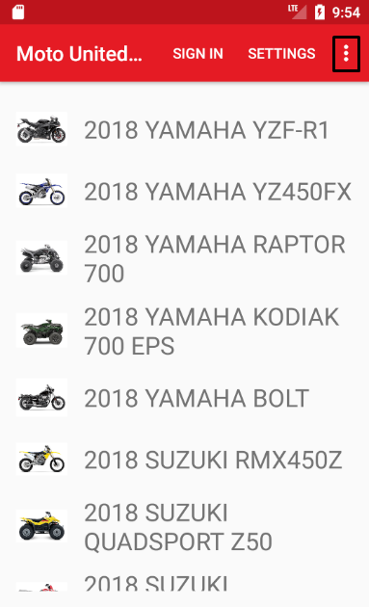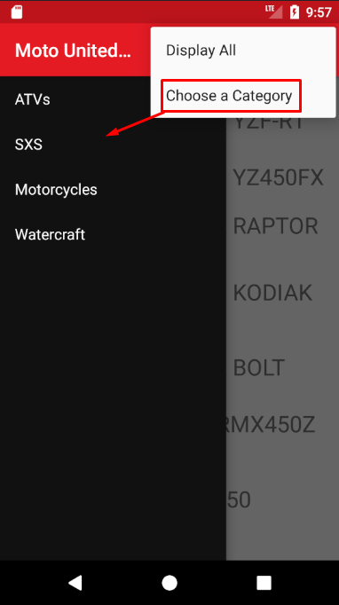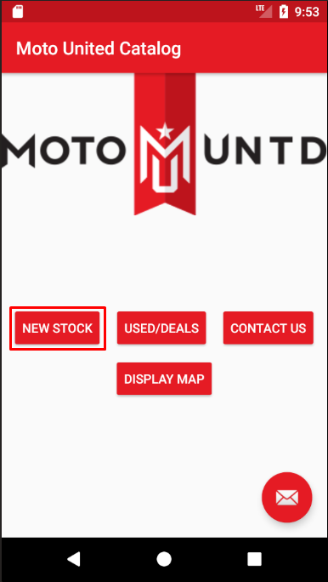2. Test Case Screenshots:

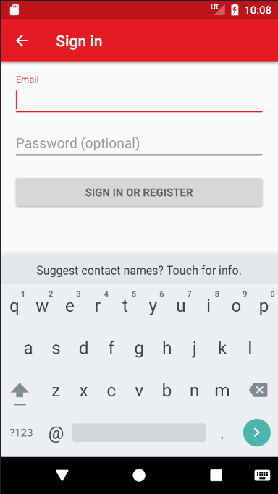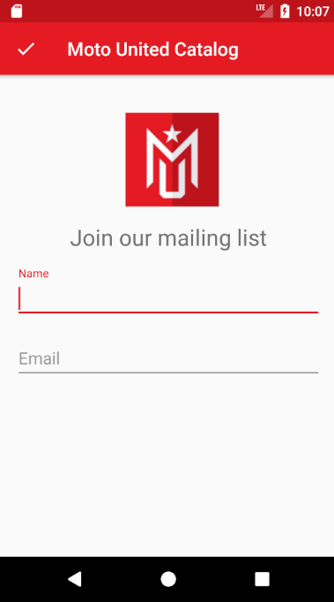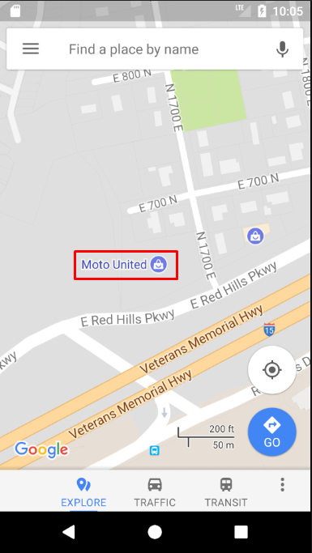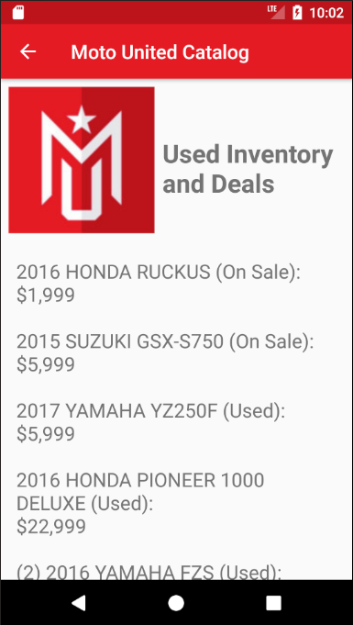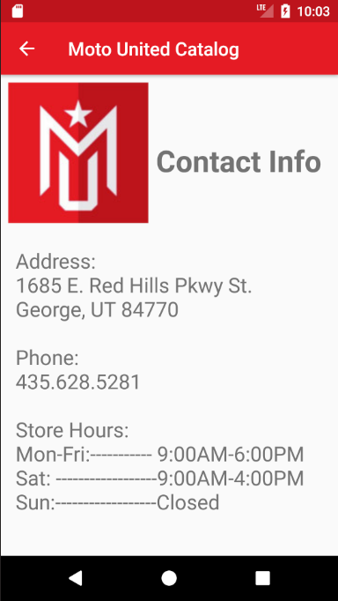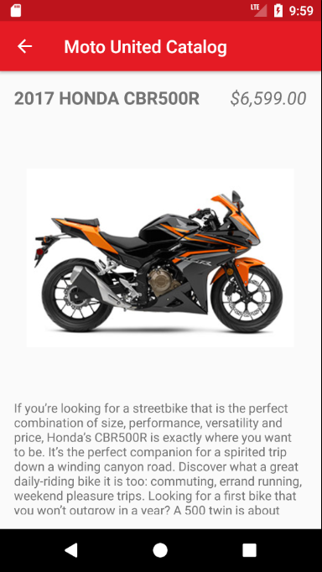

3. Difficulties I faced while designing the app and how I solved them:

The biggest problem that I have had when building any app, including this final app, is version control. It feels like I might have to reinstall android studio from scratch, because some SDKs and APIs won’t install for me. This is a big reason why I didn’t flesh out the Map Display as much as I wanted to, the google API wouldn’t install, which wouldn’t allow me to make full use of all the different mapping tools they provide. Another difficulty was the tedious database building. In order to get a lot of the stock Moto United provided I had to download pictures, record prices, and create descriptions of each individual item. This was more of just a timely process and not too difficult. The last one I can think of was a strange visual bug I found trying to create my layout files. No matter what I would do the display would show a gray screen and nothing more. I ended up fixing this by updating my app to android 26 while messing with the manifest and gradle till it started to display again.

4. Plans to improve the functionalities of the app in future.

The biggest improvement that I would do is make the map much more useful. Rather than just showing the coordinates of Moto United, have it actually take you there via google maps. Another improvement I would add would probably be another data base for Used/Deal powersports so they look just as sleek as the new catalog. Linking social media to the app would be nice too, so the user could easily find Moto United’s facebook page, etc. A way to favorite certain powersports would be a nice feature as well, where when you sign in it actually keeps track of what you favorite.

Overall I enjoyed making this final app and I also learned very useful information from taking your class, thank you for everything!